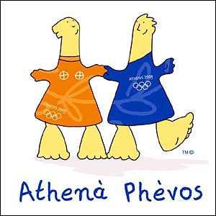
CHILDREN’S PARTY
Ages 4 and up
(must be toilet trained or accompanied by a sitter)

OCT. 15th, 2010
9am to 4pm

ACTIVITIES INCLUDE
TAG - Totally Awesome Games

Warm up games and activities, icebreakers, board games
Balloon volleyball
3-legged soccer
Giant Jenga Challenge
Obstacle Course Relay
Rookery Challenge
Mini Golf
Team Scavenger Hunts
Kick Ball

Water balloon toss

Water carry

Beach ball volleyball challenge
Tug of war
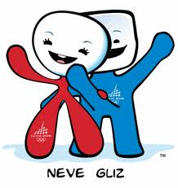

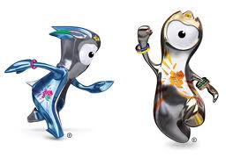

iPricing: $60 per child with a minimum guarantee of 46 participants. A $25 late fee will be added to any child not picked up by 4pm.

